./

GENESIS

**Learning Report on**

**MODEL BASED SYSTEM ENGINEERING**

**(MBSE)**

(MBSE)



|  |  |  |  |  |  |
| --- | --- | --- | --- | --- | --- |
| **Ver. Rel. No.** | **Release Date** | **Prepared. By** | **Reviewed By** | **To be Approved** | **Remarks/Revision Details** |
|  | 17-2-2021 | Sneha Anand |  |  |  |
|  |  |  |  |  |  |
|  |  |  |  |  |  |
|  |  |  |  |  |  |
|  |  |  |  |  |  |

**Details**

TABLE OF CONTENTS

Contents 3

ACTIVITY 1 : AITUOMATION SCRIPT IN MATLAB 5

___________________**1.1 AUTOMATION 5**

**___________________****1.2 AUTOMATION SCRIPT USING MATLAB TO FETCH DATA FROM A WEBSITE 5**

ACTIVITY 2 : ALGORITHM DEVELOPMENT USING SENSOR DATA FROM ANDROSENSOR _____________APPLICATION 6

ACTIVITY 3 : model based design of a differential equation using simulink

ACTIVITY 4 : model based design of difference equation using simulink

ACTIVITY 5 : model based design AND BODY CONTROL MODULE

__________________**5.1 MODULE BASED DESIGN**

**__________________****5.2 BODY CONTROL MODULE**

**LIST OF FIGURES**

**Figure 1: CODE SNIPPET OF AUTOMATION SCRIPT** Error! Bookmark not defined.

**Figure 2: PLOT INDICATING THE USE OF PHONE/ DEVICE USING GYROSCOPE READING FROM ______ANDRO-SENSOR DATA** Error! Bookmark not defined.

**Figure 3: Longitudinal Torsion** Error! Bookmark not defined.

**Figure 4: Auto-adjusting Feature of steering** Error! Bookmark not defined.

**Figure 5:** [**Body Control Module (BCM) in Automotive**](https://www.google.com/url?sa=i&url=https%3A%2F%2Fwww.intellias.com%2Fbody-control-module-bcm-in-automotive%2F&psig=AOvVaw21Ubfks1YCJBAQ1RDxQsu5&ust=1613578037492000&source=images&cd=vfe&ved=0CA0QjhxqFwoTCPiRq-Pk7u4CFQAAAAAdAAAAABAD)  **6**

**FIGURE 6: THE INTERIOR LIGHT SYTEM 10**

**FIGURE 7: THE SUBSYSTEM FOR INTERIOR LIGHT 10**

**Figure 8: Internal structure of subsystem** Error! Bookmark not defined.

# ACTIVITY 1

**AUTOMATION SCRIPT IN MATLAB**

### 1.1 AUTOMATION

Automation is a broad term that can cover many areas of technology where human input is minimized. This can include everything from business-specific types such as: business process automation (BPA), IT automation, marketing automation and industrial automation. It also covers personal applications such as home automation.

Usually, automation is employed to minimize labor or to substitute humans in the most menial or repetitive tasks. For example, most manufacturing plants make use of some automated process in the form of robotic assembly lines. Human input is required only to define the processes and supervise them, while the assembling of the various components is left to the machines, which automatically convert raw materials into finished goods.

In the information technology domain, a software script can test a software product and produce a report.

### 1.2 AUTOMATION SCRIPT USING MATLAB TO FETCH DATA FROM A WEBSITE

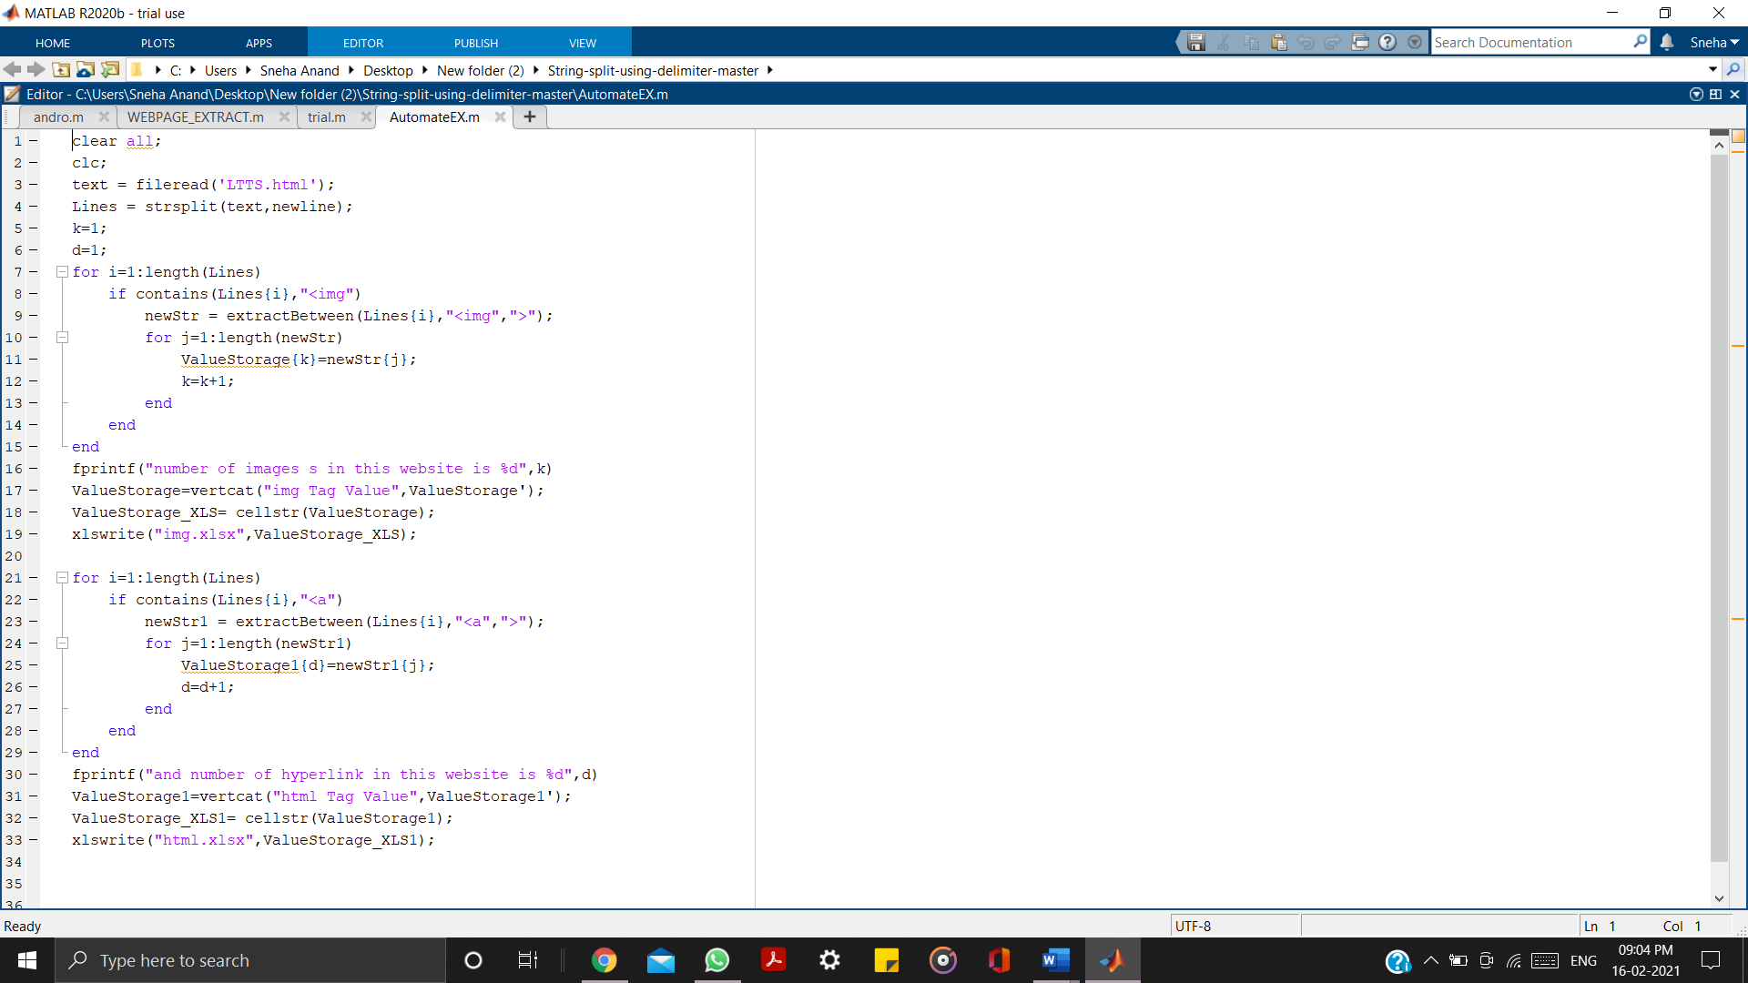

[**Link to MATLAB Code:**](https://github.com/99003525/MBSE/blob/main/MATLAB/AutomateEX.m)

**Links to Excel file**s:

1. [Webpage used](https://github.com/99003525/MBSE/blob/main/MATLAB/html.xlsx)
2. [HTML tag data](https://github.com/99003525/MBSE/blob/main/MATLAB/html.xlsx)
3. [Images data](https://github.com/99003525/MBSE/blob/main/MATLAB/img.xlsx)

Figure 1: Code snippet of automation script

# ACTIVITY 2

**ALGORITHM DEVELOPMENT USING SENSOR DATA FROM ANDROSENSOR APPLICATION**

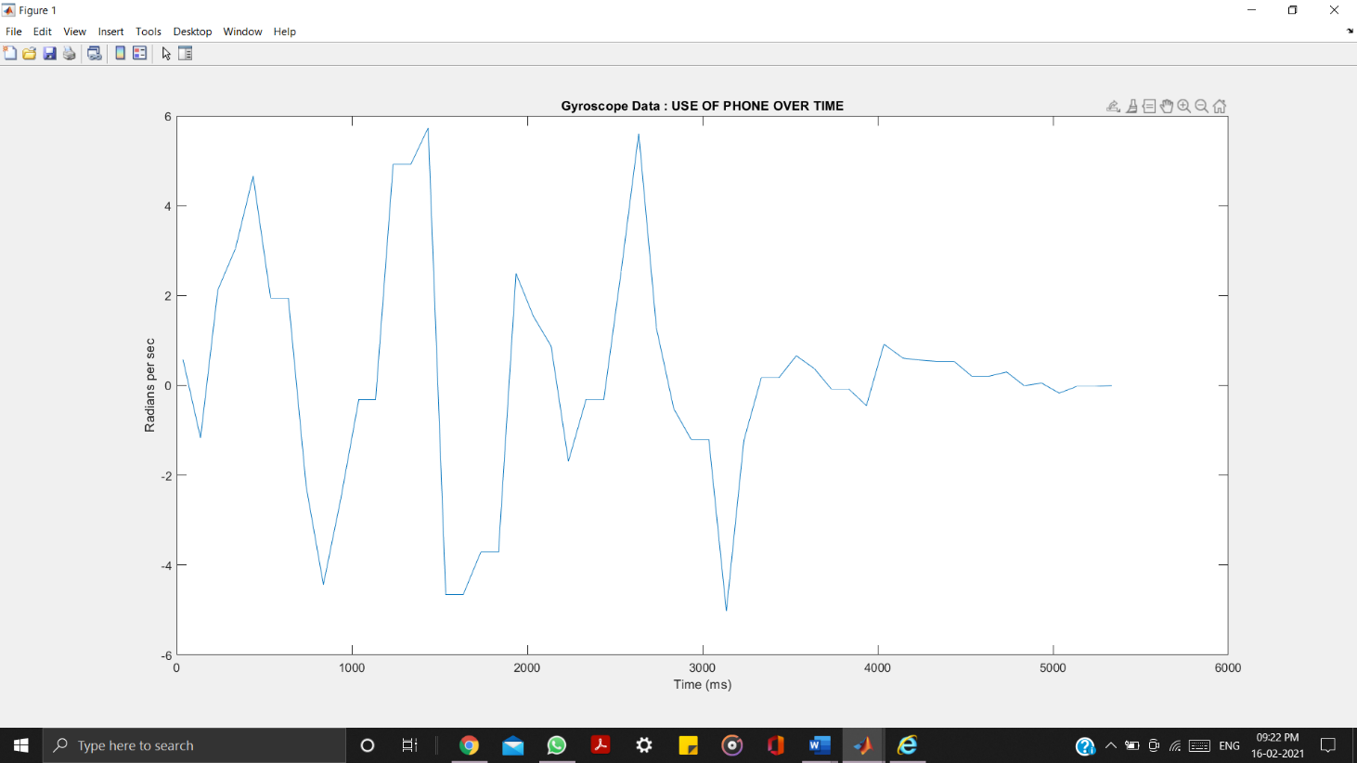

Figure 2: Plot indicating the use of phone / device using gyroscope reading from Andro-sensor Data

[**Link to MATLAB Code**](https://github.com/99003525/MBSE/blob/main/MATLAB/Algorithm_matlab.m)

[**Link to Excel file**](https://github.com/99003525/MBSE/blob/main/MATLAB/sample.csv)

# ACTIVITY 3

**MODEL BASED DESIGN OF A DIFFERENTIAL EQUATION USING SIMULINK**

# ACTIVITY 4

**MODEL BASED DESIGN OF A DIFFERENCE EQUATION USING SIMULINK**

**ACTIVITY 5**

**MODEL-BASED DESIGN AND BODY CONTROL MODULE**

**5.1** [**MODEL-BASED DESIGN (MBD)**](https://en.wikipedia.org/wiki/Model-based_design)

MBD is a mathematical and visual method of addressing problems associated with designing complex control,[]](https://en.wikipedia.org/wiki/Model-based_design#cite_note-1) signal processing and communication systems. It is used in many motion control, industrial equipment, aerospace, and automotive applications Model-based design is one solution that substitutes the traditional approach to automotive software development.

In model-based design of control systems, development is manifested in these four steps:

1. modeling a plant,
2. analyzing and synthesizing a controller for the plant,
3. simulating the plant and controller,
4. integrating all these phases by deploying the controller.

The model-based design is significantly different from traditional design methodology. Rather than using complex structures and extensive software code, designers can use Model-based design to define plant models with advanced functional characteristics using continuous-time and discrete-time building blocks. These built models used with simulation tools can lead to rapid prototyping, software testing, and verification.

Not only is the testing and verification process enhanced, but also, in some cases, hardware-in-the-loop simulation can be used with the new design paradigm to perform testing of dynamic effects on the system more quickly and much more efficiently than with traditional design methodology.

Model-based design allows faster releases, enhanced design, and better reliability in automotive embedded systems. Tools for software modeling and simulation can improve automotive systems as long as they continue to demonstrate benefits and become more common in the industry.

**5.2 BODY CONTROL MODULE**

In automotive electronics, **body control module** or 'body computer' is a generic term for an electronic control unit responsible for monitoring and controlling various electronic accessories in a vehicle's body. Typically in a car the BCM controls the power windows, power mirrors, air conditioning, immobilizer system, central locking, etc. The BCM communicates with other on-board computers via the car's vehicle bus, and its main application is controlling load drivers – actuating relays that in turn perform actions in the vehicle such as locking the doors or dimming the interior lighting.

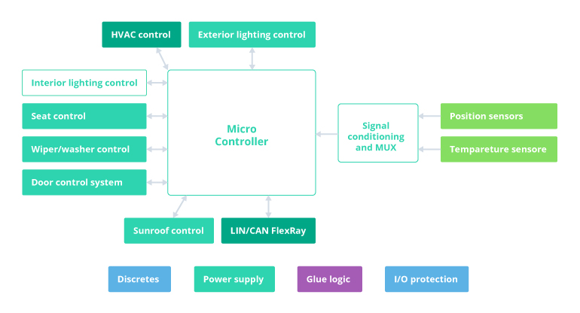

Figure 5: [Body Control Module (BCM) in Automotive](https://www.google.com/url?sa=i&url=https%3A%2F%2Fwww.intellias.com%2Fbody-control-module-bcm-in-automotive%2F&psig=AOvVaw21Ubfks1YCJBAQ1RDxQsu5&ust=1613578037492000&source=images&cd=vfe&ved=0CA0QjhxqFwoTCPiRq-Pk7u4CFQAAAAAdAAAAABAD)

A BCM can perform multiple control-related operations simultaneously. One of the major objectives of this module is to detect malfunctions in the work of electrical system components.

**5,3 MBD OF BCM : Internal Lighting**

**TEST PLAN:**

|  |  |  |  |  |
| --- | --- | --- | --- | --- |
|  |  |  |  |  |
|  |  |  |  |  |
|  |  |  |  |  |
|  |  |  |  |  |
|  |  |  |  |  |
|  |  |  |  |  |
|  |  |  |  |  |
|  |  |  |  |  |
|  |  |  |  |  |
|  |  |  |  |  |
|  |  |  |  |  |
|  |  |  |  |  |
|  |  |  |  |  |
|  |  |  |  |  |
|  |  |  |  |  |
|  |  |  |  |  |
|  |  |  |  |  |
|  |  |  |  |  |
|  |  |  |  |  |
|  |  |  |  |  |
|  |  |  |  |  |

Table 1: Test Plan

[**Link to Simulink Model**](https://github.com/99003525/MBSE/blob/main/SIMULINK/interior_light.slx)

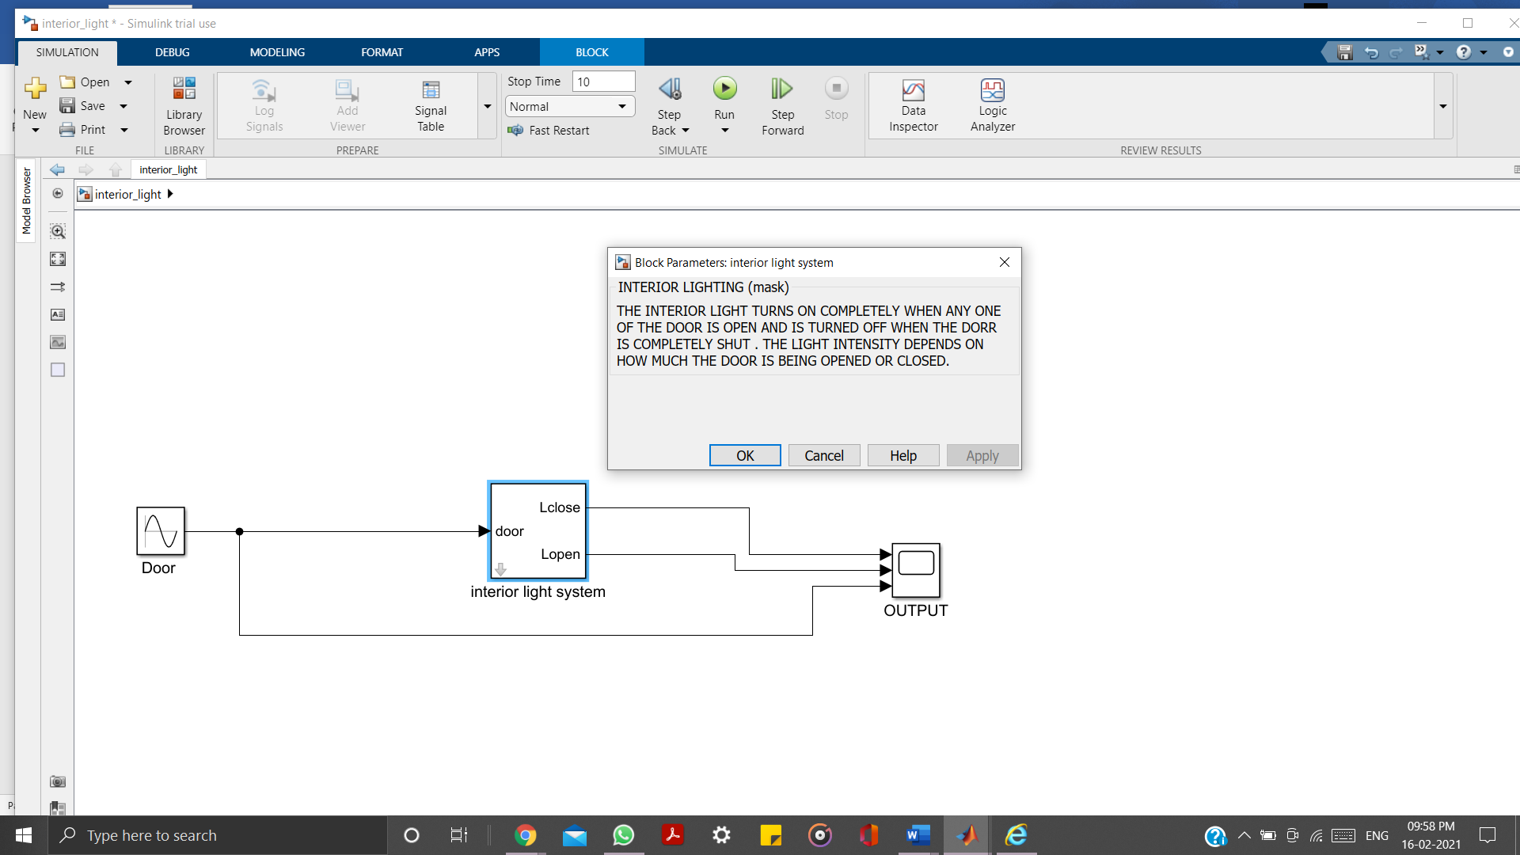

Figure 6: The interior light system

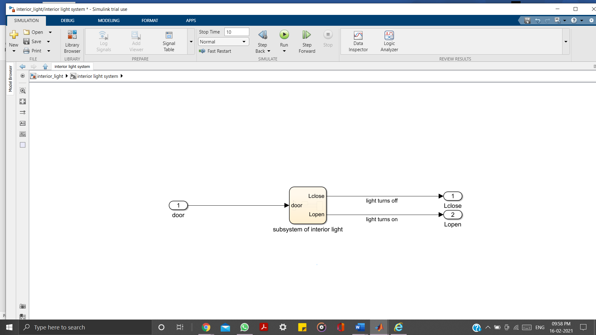

Figure 7 : The interior lighting subsystem

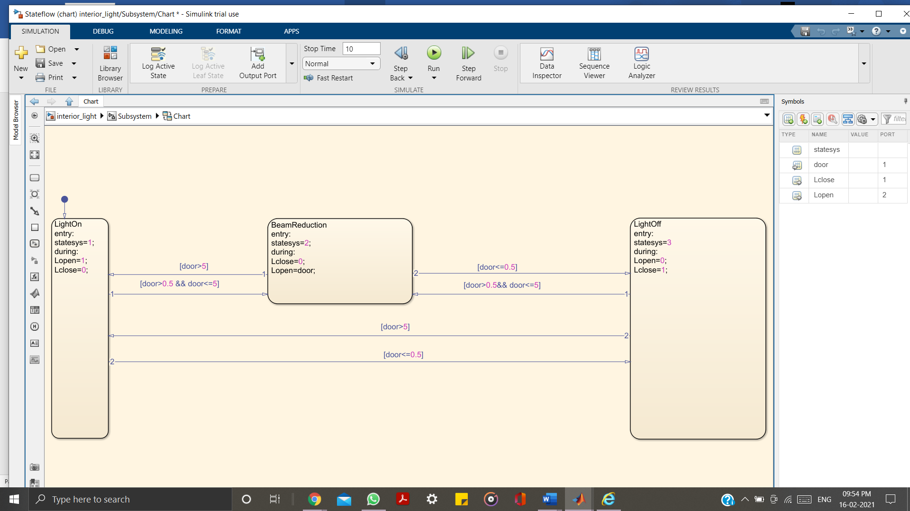

Figure 8 : Internal structure (Stateflow) of the subsystem

**6. CERTIFICATES**

**MATLAB ONRAMP CERTIFICATE:**



**SIMULINK ONRAMP CERTIFICATE:**



**STATEFLOW ONRAMP CERTIFICATE:**

